

V 1.0
March 2026
XStep Design Specification
SMPL: Probe Information

Table of Contents
Functional Requirements 3
1 Purpose 3
2 Overview 3
3 Reasons for developing 4
4 Authorization 4
5 Assumptions/ Dependencies 4
6 Validation Checks 4
7 Configuration Specifications 4
8 Test Scenarios 5
9 Document References 5
10 Revision History 5

Purpose
This document outlines the functional and technical design, along with the configuration specifications for the XStep “SMPL: Probe Information”.

Overview
The SMPL: Probe Information allows operators to select the specific $pO_{2}$ probe or pH probe information.
The XStep contains the following main input parameters:
- IV_HEADER - This can be changed in SiMPL MBR to display specific header text for the XStep
- IV_INSTR - This can be changed in SiMPL MBR to display a specific set of instructions for the XStep that will be displayed below the header
- IV_TITLE1 - This can be changed in SiMPL MBR to display the specific field label for the value being recorded. By default it is set to “Probe” but can be changed to anything applicable
- IV_TITLE2 - This can be changed in SiMPL MBR to display the specific field label for the value being recorded. By default it is set to “Probe Type” but can be changed to anything applicable.
- IV_TITLE3 - This can be changed in SiMPL MBR to display the specific field label for the value being recorded. By default it is set to “Serial Number” but can be changed to anything applicable.
- IV_TITLE4 - This can be changed in SiMPL MBR to display the specific field label for the value being recorded. By default it is set to “Temperature” but can be changed to anything applicable.
- IV_TITLE5 - This can be changed in SiMPL MBR to display the specific field label for the value being recorded. By default it is set to “Baseline/Zero value” but can be changed to anything applicable.
- IV_TITLE6 - This can be changed in SiMPL MBR to display the specific field label for the value being recorded. By default it is set to “Slope Value” but can be changed to anything applicable.
- IV_TITLE7 - This can be changed in SiMPL MBR to display the specific field label for the value being recorded. By default it is set to “100% Saturation” but can be changed to anything applicable.
Functional Design
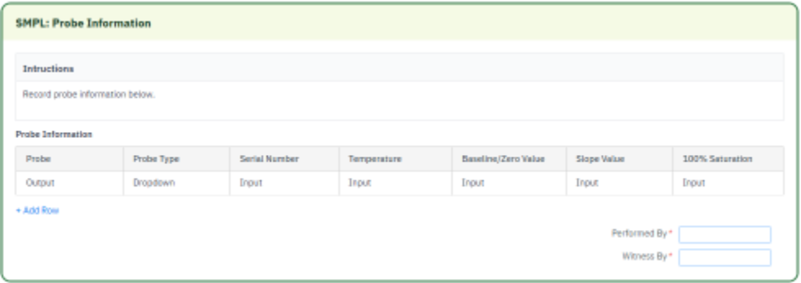

Reasons for developing
The SMPL: Probe Information was developed to provide a singular, consolidated execution step for entry of $pO_{2}$ probe or pH probe information. The configuration of default values guides the operator regarding which fields are mandatory versus optional based on the use case.

Authorization
N/A

Assumptions/ Dependencies
 | Assumption
1 | Master Data has been set up correctly

Validation Checks
Error Handling
Error | Action

Configuration Specifications
N/A

Test Scenarios
# | Scenario | Expected Result | Actual Result | Pass/ Fail

Document References
Reference No. | Document Title

Revision History
Version No. | Description | Author | Date

